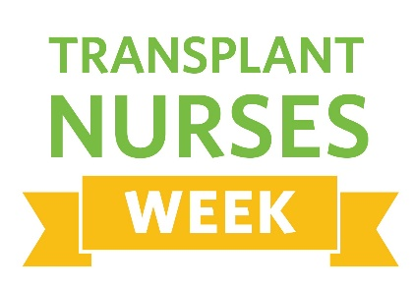
April 25 – May 2, 2022

To Whom it May Concern:
I am writing to inform you that Transplant Nurses Week (TNW) will be celebrated April 25 through May 2, 2022.
The International Transplant Nurses Society (ITNS) created Transplant Nurses Week to raise awareness of the unique contributions transplant nurses make in the lives of the people with whom they work, especially their patients.
As awareness of this important profession grows, ITNS is committed to creating more opportunities for nurses, healthcare professionals, organ donors and recipients, and their families to show their appreciation for the incredible care transplant nurses provide around the world.
We invite you to honor your transplant nurses and other transplant professionals during this week, and help spread the word to your colleagues, patients, and families about Transplant Nurses Week. This is an excellent opportunity to show support to those who make an impact each and every day to transplant patients and their families, as well as their colleagues.
We are excited to see what will be shared on the TNW virtual bulletin board and on social media as transplant nurses are celebrated throughout the week.
Visit https://www.itns.org/transplant-nurses-week for ways to celebrate and help spread the word. Please feel free to contact Member Services at info@itns.org or +1 847.375.6340 with any questions.
Sincerely,
Paula Eicker, RN MSN NEA-BC CCRC
President
International Transplant Nurses Society

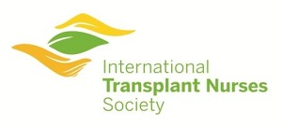

8735 W. Higgins Road, Suite 300, Chicago, IL 60631
+ 1 847 375.6340 (phone) • + 1 847 375.6341 Attn: ITNS (fax)
Email: info@itns.org

